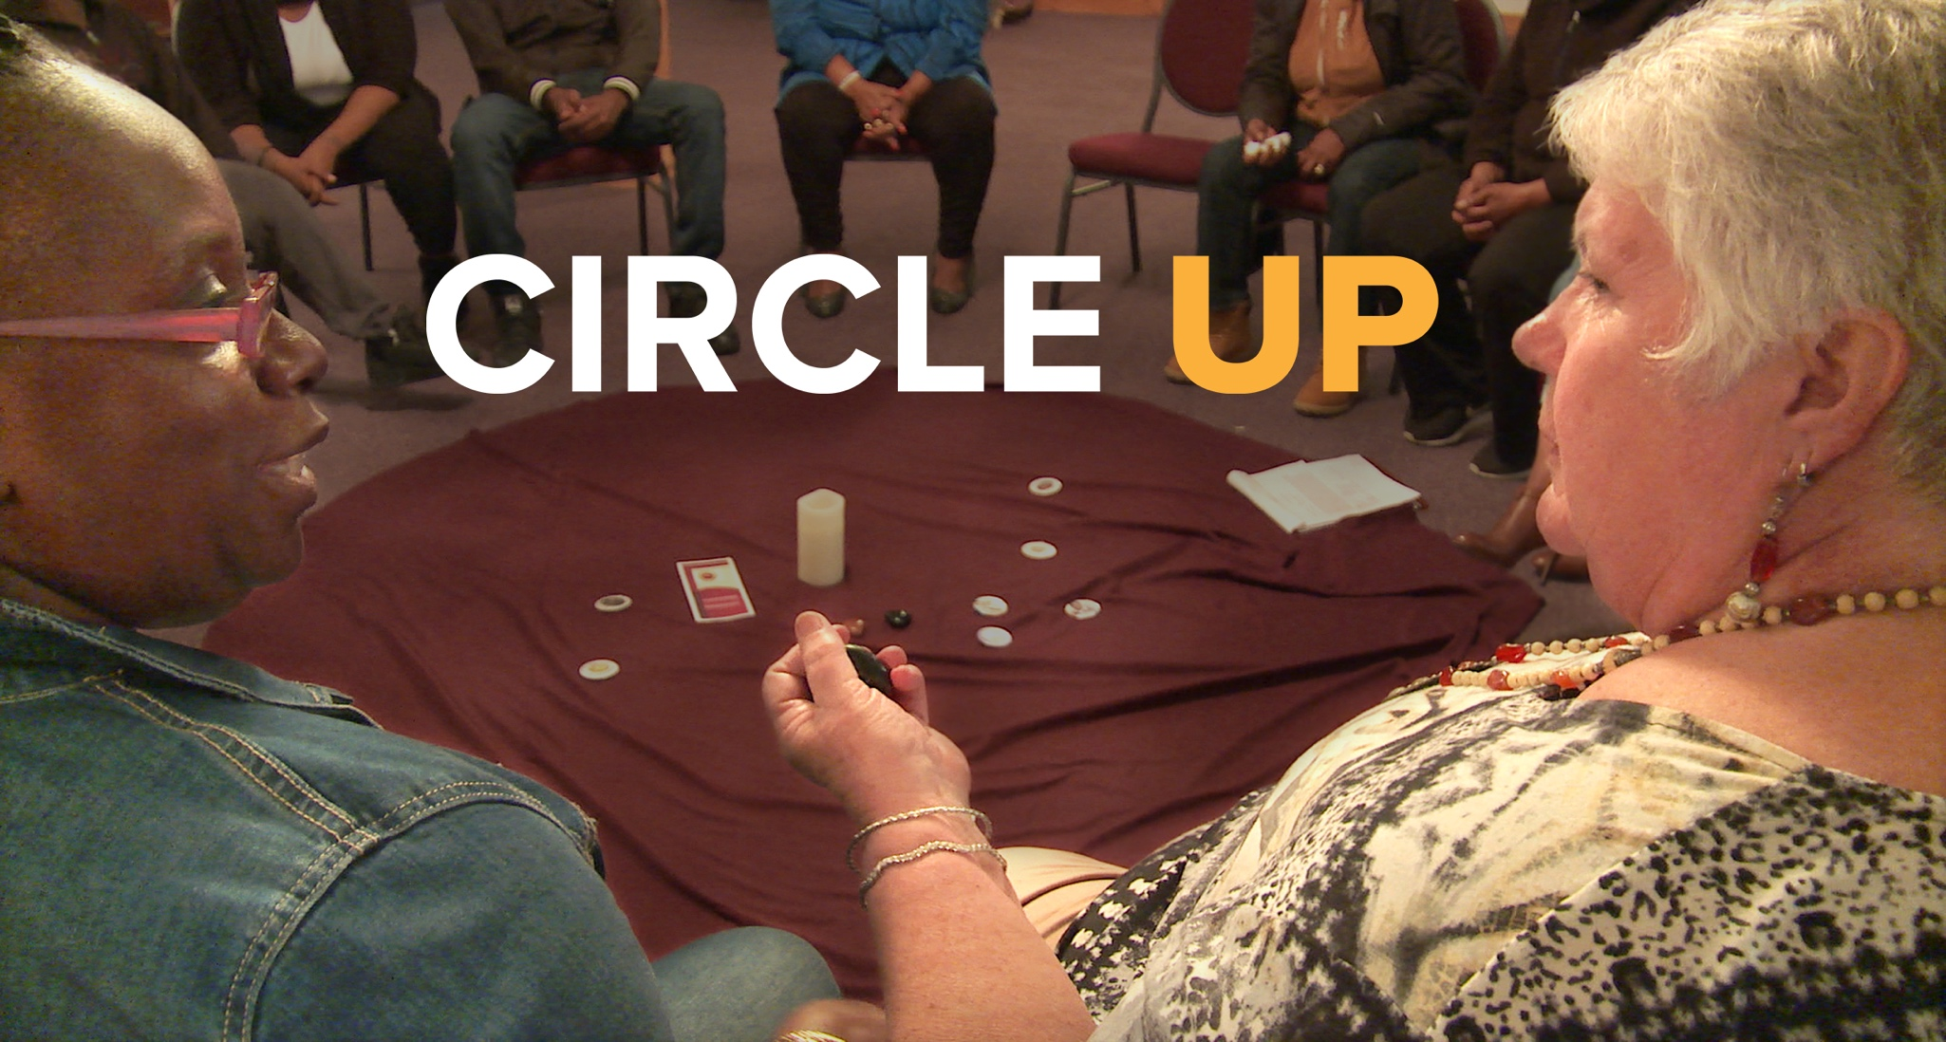

A DOCUMENTARY FILM SCREENING

Screening Date and Time

Venue

Address

After the brutal slaying of her teenage son, Janet Connors reaches out to her son's killer to offer a chance at forgiveness. They team up with a t of mothers of murdered children to help young people in their community break the chain of violence and revenge.
Circle Up is a call to action for reframing approaches to crime and punishment through the lens of restorative justice, forgiveness, and accountability.
www.circleupdoc.com

Organization Website | Organization Contact Information | 0rganization Logo

